Circular Doubly Linked List In Java
A circular doubly linked list is one of the complex structures. In this list, the last node of the doubly linked list contains the address of the first node and the first node contains the address of the last node. Thus in a circular doubly linked list, there is a cycle and none of the node pointers are set to null.
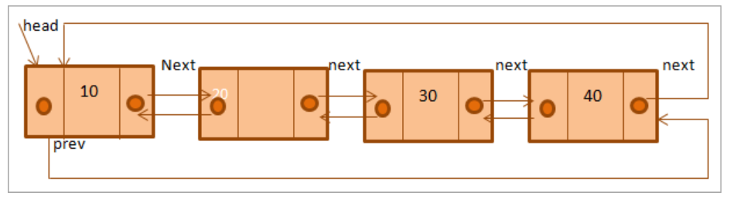
Fig 1: Graphical representation
Advantages of a Circular Double Linked List:
- The circular doubly linked list can be traversed from head to tail or tail to head.
- Going from head to tail or tail to head is efficient and takes only constant time O (1).
- It can be used for implementing advanced data structures including Fibonacci heap.
Disadvantages:
- As each node needs to make space for the previous pointer, extra memory is required.
- We need to deal with lots of pointers while performing operations on a circular doubly linked list. If pointers are not handled properly, then the implementation may break.

Code:
import java.util.*;

class Main{
static Node head;
// Doubly linked list node definition
static class Node{
int data;
Node next;
Node prev;
};

// Function to insert node in the list
static void addNode(int value) {
// List is empty so create a single node furst
if (head == null) {
Node new_node = new Node();
new_node.data = value;
new_node.next = new_node.prev = new_node;
head = new_node;
return; }
// find last node in the list if list is not empty
Node last = (head).prev; //previous of head is the last node
// create a new node
Node new_node = new Node();
new_node.data = value;
// next of new_node will point to head since list is circular
new_node.next = head;
// similarly previous of head will be new_node
(head).prev = new_node;
// change new_node=>prev to last
new_node.prev = last;
// Make new node next of old last
last.next = new_node;
}

static void printNodes() {
Node temp = head;
//traverse in forward direction starting from head to print the list
while (temp.next != head)
{
System.out.printf("%d ", temp.data);
temp = temp.next;
}
System.out.printf("%d ", temp.data);

//traverse in backward direction starting from last node
System.out.printf("\nCircular doubly linked list travesed backward: \n");
Node last = head.prev;
temp = last;
while (temp.prev != last)
{
System.out.printf("%d ", temp.data);
temp = temp.prev;
}
System.out.printf("%d ", temp.data);
}

public static void main(String[] args)
{
//the empty list
Node l_list = null;

// add nodes to the list
addNode(40);
addNode(50);
addNode(60);
addNode(70);
addNode(80);

//print the list
System.out.printf("Circular doubly linked list: ");
printNodes();
}
}

